Basic Framework of Geography
What is Geography?
“Geo” is Latin for earth
“Graphy” is Greek for graph or map.
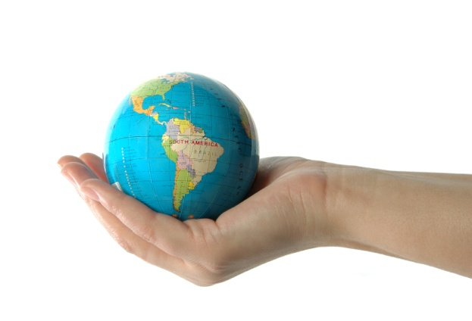
So…Geography is the mapping of the earth, looking for patterns, processes and interrelationships.
Pose and Answer Geographic Questions:
- Where is it located?

- Why is it there? Why not here?

- What is significant about its location? What are the consequences?

- How is its location related to the location of other people, places, and environments?
5 Themes of Geography
- Location (Absolute and Relative)
- Place (What makes it unique?)
- Movement (How did goods, ideas and people get there and how does the movements associated with the earth affect mankind – wind, weather, water, tectonics – earthquakes, volcanoes…)

- Human/Environment interaction (Both positive and negative aspects that affect mankind)
- Region – the Geographers way to categorize specific traits of an area, but is an imaginary boundary.
Maps (Cannot say enough about using maps – ALL types of maps)
- Maps are the language of Geography.
- Use thematic maps to teach the patterns, processes and interrelationships.
Vocabulary
Geographic terminology is extremely important, along with the wording of questions and how the vocabulary is
used in the stems and answers.
Foundational Concepts of Geography – (Patterns, Processes, and Interrelationships)

Physical Geography Human Geography
Landscape Political/Government/Boundaries
Biomes Cultural
Water Economics
Climate Population
Urban Systems

When teaching any social studies course, especially Geography the key to learning is the application of information by using the Skills Strand of the TEKS to specific real world situations.

